Blood banks waste 2.8 million units in 5 years

<https://timesofindia.indiatimes.com/city/mumbai/blood-banks-waste-2-8m-units-in-5-yrs/articleshow/58333394.cms?from=mdr>

MUMBAI: In the last five years, over 2.8 million precious of, exposed serious in the nation’s banking system. The cumulative wastage of around 6%, if calculated in liters, is more than 6 lakh liters—a volume enough to fill up 53 water tankers.

States like Maharashtra, Uttar Pradesh, Karnataka, and Tamil Nadu were among the worst offenders, discarding not just whole blood but even life-saving components such as red blood cells and plasma as the life-saving products could not be used before the end of their shelf life.

In 2016-17 alone, over 6.57 lakh units of blood and its products were discarded. The worrying part is that 50% of the units were plasma which has a longer shelf life of one year as compared to whole blood and red blood cells units blood and its components were discarded by blood banks across the country loopholes blood wasted that have to be used within 35 days.

The spoilage was revealed by data provided by the (NACO) in response to an RTI query by Chetan Kothari. Maharashtra, the only state to have crossed the one million mark in, also topped the dubious list with maximum wastage of whole blood followed by West Bengal and Andhra Pradesh. Maharashtra, UP, and Karnataka bagged the top three positions in discarding the highest units of red blood cells. UP and Karnataka wasted the maximum units of fresh frozen plasma. In 2016-17, over 3 lakh units of fresh frozen plasma were discarded, which is ironic given that the product is imported by several pharma companies to produce albumin.

“The figures are alarming because blood shortage is a chronic problem in our country. It exists everywhere, right from the most interior parts of the country to metros like Delhi and Mumbai. Delhi alone faces an annual shortage of 1lakh units,” said Kothari. India has an annual shortfall of 3 million units of blood. Lack of blood, plasma, or platelets often becomes the cause of maternal mortality and deaths in accident cases.

Crusaders for safe blood blamed the crisis on the absence of a robust blood-sharing network between the hospitals. Mass camps have particularly come under fire with many blaming the local politicians for using blood donation camps as an easy tool to please their constituencies. Dr. Zarine Bharucha of the Indian Red Cross Society said that a collection of up to 500 units is what is acceptable and manageable. “But we have seen and heard of camps where 1,000 to 3,000 units of blood is collected. There is no way to screen a donor or take their medical history. Most importantly, where is the place to store so much blood,” she said, adding that what is needed is patient awareness. “Why can’t people walk into regular banks and donate once every three months,” she said.

A single unit of whole blood can be broken into components such as red blood cells, plasma, and platelet. However, most government-owned blood banks don’t have fractionalization facilities that can process the blood and break it into components. “This alone results in a huge wastage as doctors nowadays insist on transfusing components. A physician treating a dengue patient, for instance, would prefer to give a platelet transfusion instead of unnecessarily pumping the patient with bottles of whole blood,” said a senior blood bank officer. States like West Bengal are mostly issuing whole blood instead of the components, which is indicative of its outdated banking methods.

## 

## **Facts About Blood and Blood Types**

<https://www.redcrossblood.org/donate-blood/blood-types.html>

How Blood Type Is Determined And Why You Need To Know

Blood types are determined by the presence or absence of certain antigens – substances that can trigger an immune response if they are foreign to the body. Since some antigens can trigger a patient's immune system to attack the transfused blood, safe blood transfusions depend on careful blood typing and cross-matching.

There are four major blood groups determined by the presence or absence of two antigens, A and B, on the surface of red blood cells. In addition to the A and B antigens, there is a protein called the Rh factor, which can be either present (+) or absent (–), creating the 8 most common blood types (A+, A-, B+, B-, O+, O-, AB+, AB-).

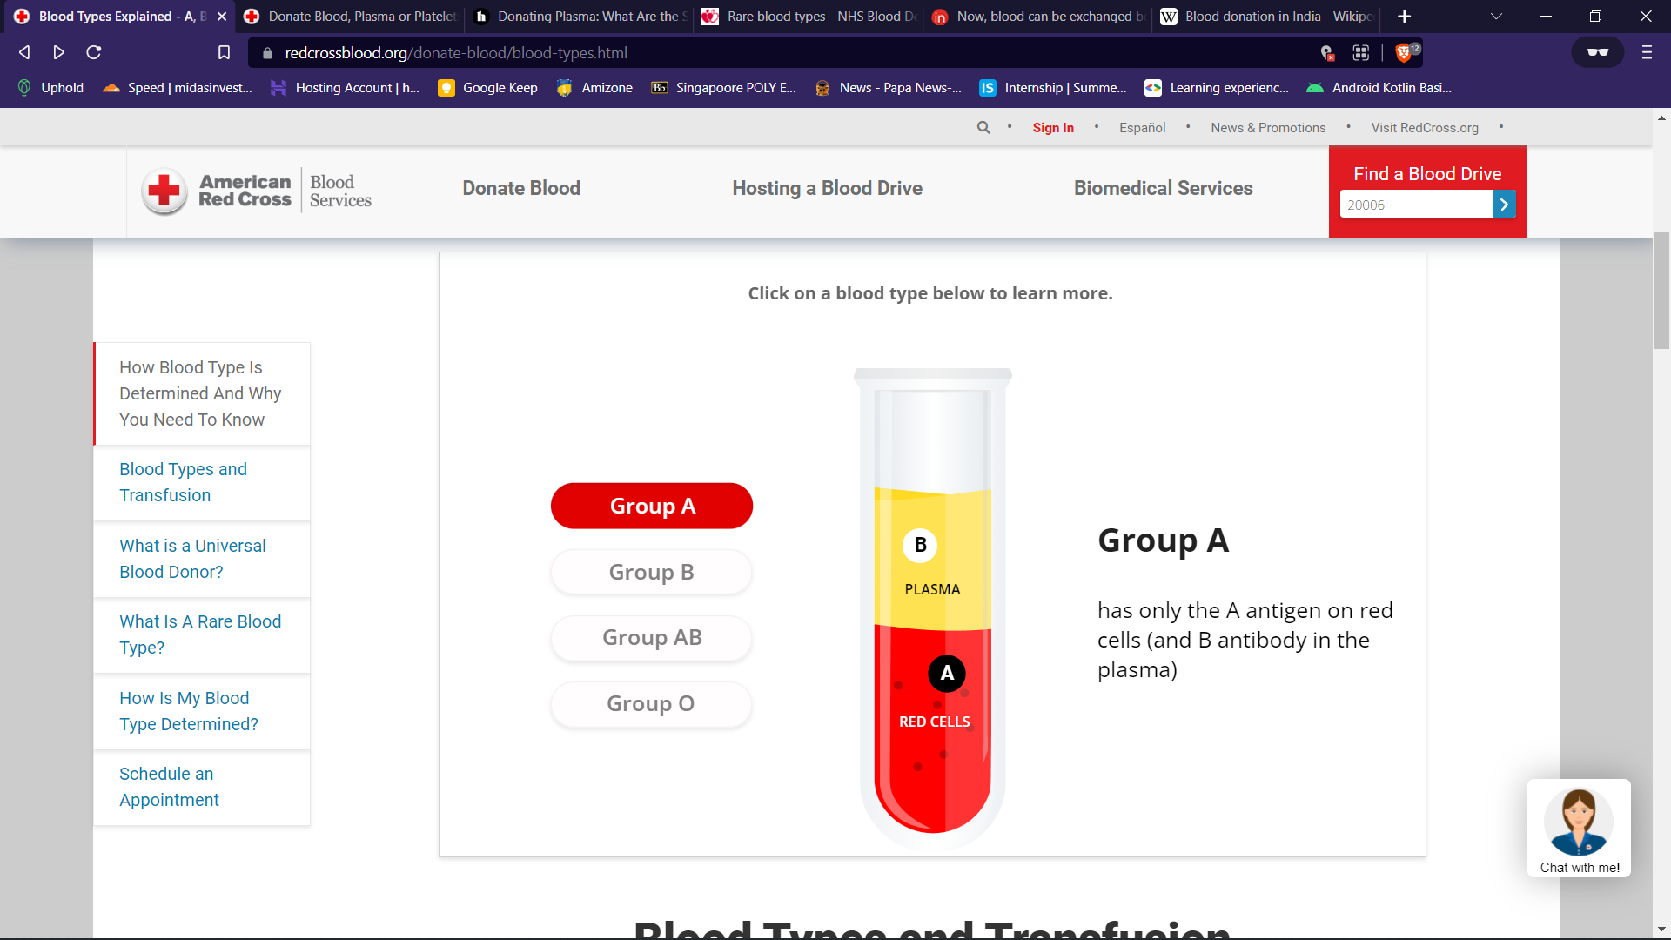

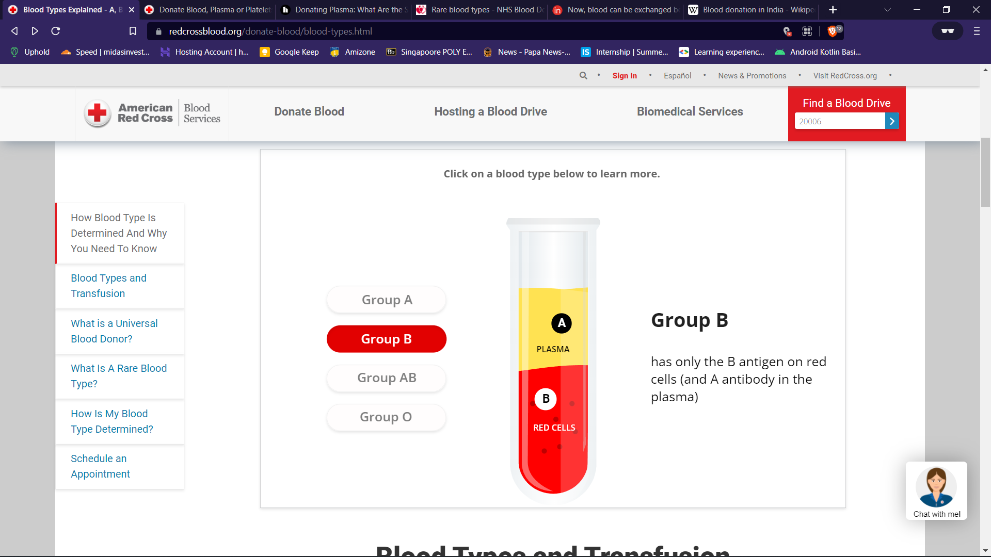

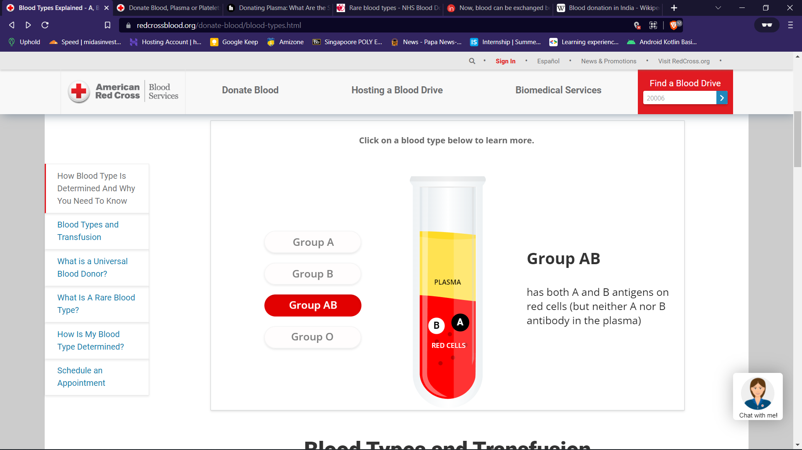

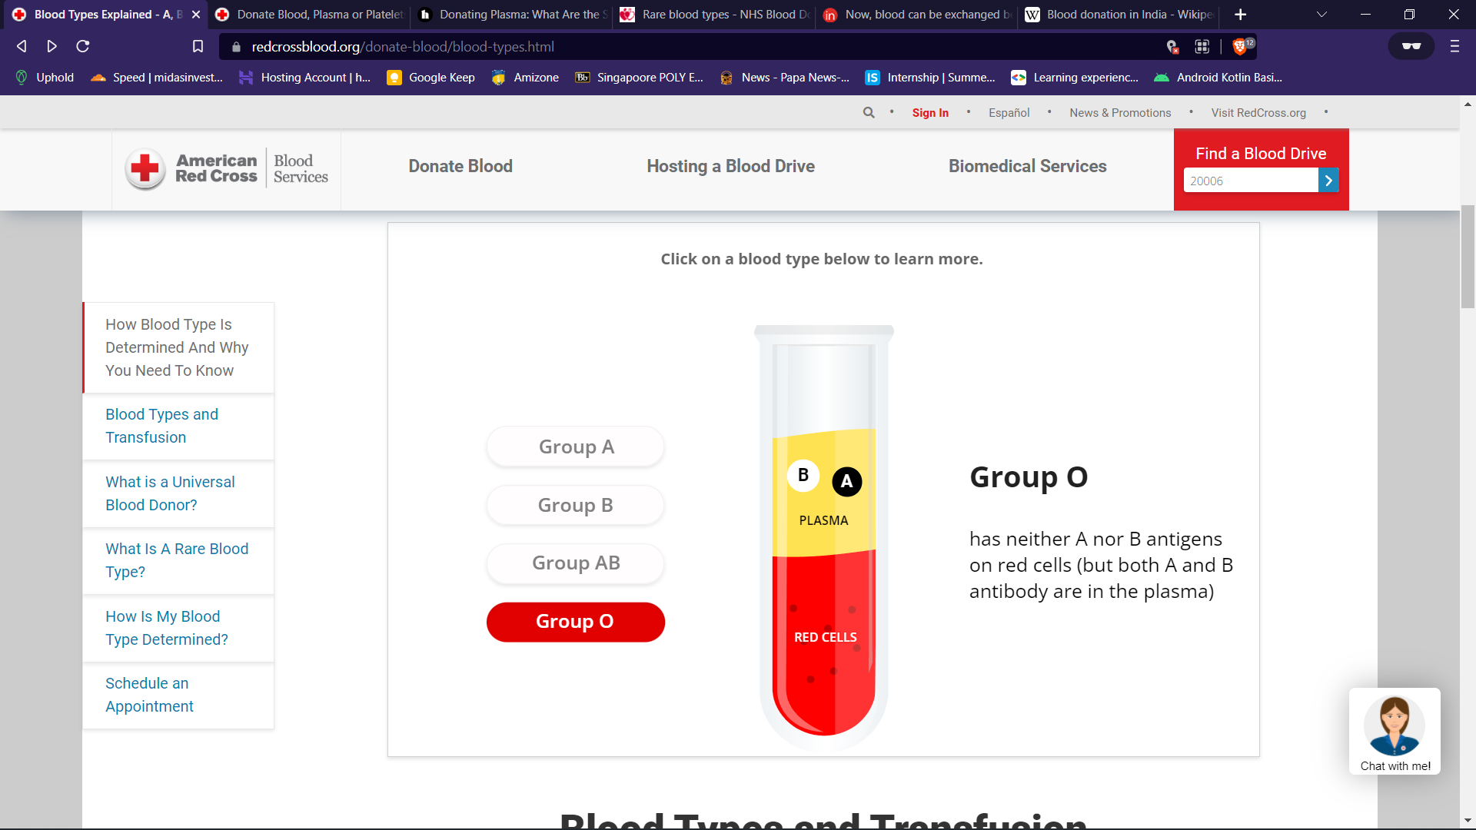

### **Blood Types and Transfusion**

There are particular ways in which blood types must be matched for a safe transfusion. The right blood transfusion can mean the difference between life and death. Use the interactive graphic below to learn more about matching blood types for transfusions.

Also, Rh-negative blood is given to Rh-negative patients, and Rh-positive or Rh-negative blood may be given to Rh-positive patients. The rules for plasma are the reverse.

* **The universal red cell donor has Type O negative blood.**
* **The universal plasma donor has Type AB blood.**

There are more than 600 other known antigens, the presence or absence of which creates "rare blood types." Certain blood types are unique to specific ethnic or racial groups. That’s why an African-American blood donation may be the best hope for the needs of patients with [sickle cell disease](https://www.redcrossblood.org/donate-blood/how-to-donate/types-of-blood-donations/blood-types/diversity/sicklecell.html), many of whom are of African descent. [Learn about blood and diversity.](https://www.redcrossblood.org/donate-blood/blood-types/diversity.html)

### **What Is A Universal Blood Donor?**

Universal donors are those with an O-negative blood type. Why? O negative blood can be used in transfusions for any blood type.

Type O is routinely in short supply and in high demand by hospitals – both because it is the most common blood type and because type O negative blood is the universal blood type needed for emergency transfusions and for immune deficient infants.

Approximately 45 percent of Caucasians are type O (positive or negative), but 51 percent of African-Americans and 57 percent of Hispanics are type O. Minority and diverse populations, therefore, play a critical role in meeting the constant need for blood.

Types O negative and O positive are in high demand. Only 7% of the population are O negative. However, the need for O-negative blood is the highest because it is used most often during emergencies. The need for O+ is high because it is the most frequently occurring blood type (37% of the population).

The universal red cell donor has Type O negative blood. The universal plasma donor has Type AB blood. For more about plasma donation, visit the plasma donation facts.

### **What Is A Rare Blood Type?**

There are more than 600 other known antigens, the presence or absence of which creates "[rare blood types](https://www.redcrossblood.org/donate-blood/dlp/rare-donors.html)." Your blood type is considered rare if you lack antigens that 99% of the people are positive for. If you somehow lack an antigen that 99.99% are positive for, your blood type is extremely rare.

### **How Is My Blood Type Determined?**

It’s inherited. Like eye color, blood type is passed genetically from your parents. Whether your blood group is type A, B, AB or O is based on the blood types of your mother and father.

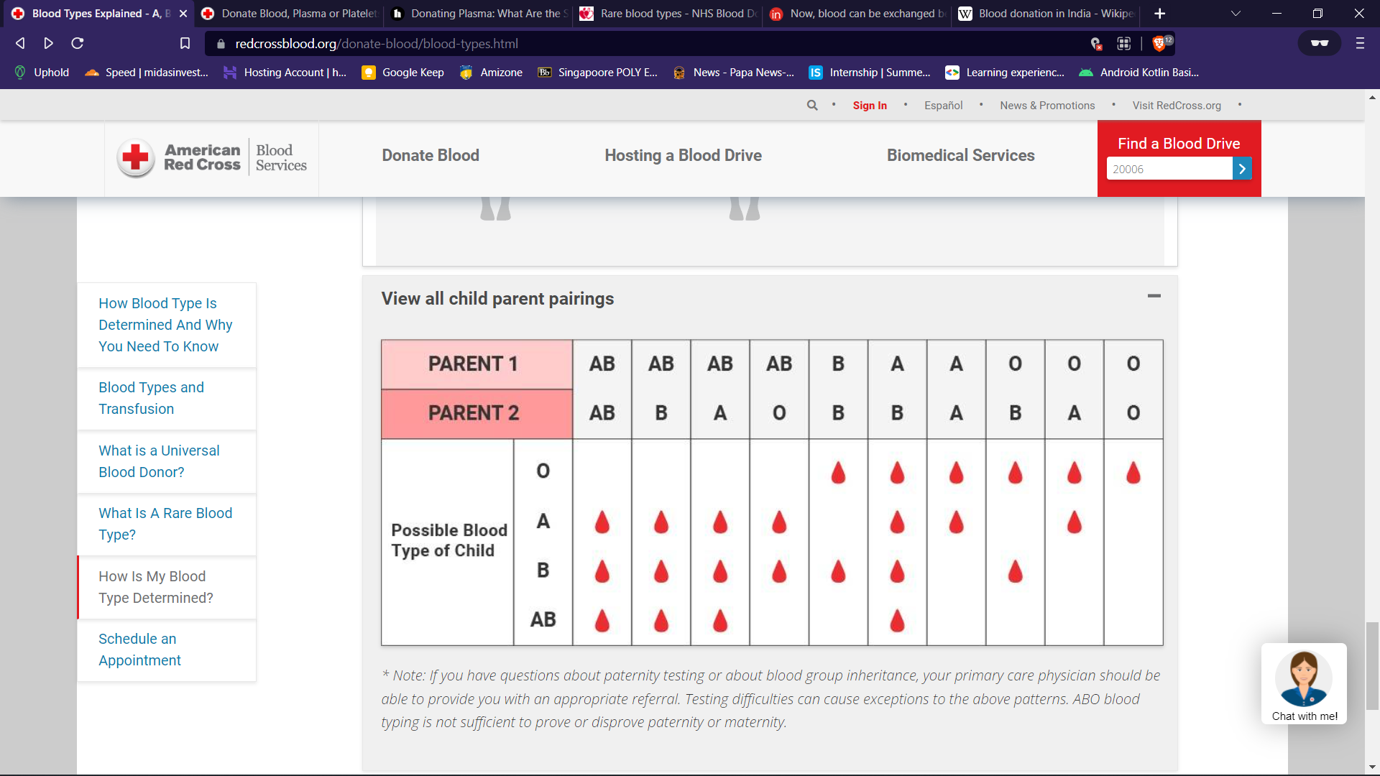

## **Types of Blood Donations**

<https://www.redcrossblood.org/donate-blood/how-to-donate/types-of-blood-donations.html>

Giving the "right" type of blood donation - based on your blood type and patient needs - helps ensure the best use of your valuable contribution. Here are some things to consider when determining how you can have the most impact.

###### Whole Blood Donation

Whole blood is the most flexible type of donation. It can be transfused in its original form or used to help multiple people when separated into its specific components of red cells, plasma, and platelets. [Learn more about whole blood donations.](https://www.redcrossblood.org/donate-blood/how-to-donate/types-of-blood-donations/whole-blood-donation.html)

**Who it helps:** Whole blood is frequently given to trauma patients and people undergoing surgery.

**Time it takes:** About 1 hour

**Ideal blood types:** All blood types

**Donation frequency:** Every 56 days, up to 6 times a year

###### Power Red Donation

During a Power Red donation, you give a concentrated dose of red cells, the part of your blood used every day for those needing transfusions as part of their care. This type of donation uses an automated process that separates your red blood cells from the other blood components, and then safely and comfortably returns your plasma and platelets to you.

With just a little extra time at your appointment, you can donate more red cells and increase your impact on patients in need. [Learn more about Power Red donations](https://www.redcrossblood.org/donate-blood/how-to-donate/types-of-blood-donations/power-red-donation.html#prelig).

**Who it helps**: Red cells from a Power Red donation are typically given to trauma patients, newborns, and emergency transfusions during birth, people with sickle cell anemia, and anyone suffering blood loss.

**Time it takes:** About 1.5 hours

**Ideal blood types:** O positive, O negative, A negative, and B negative

**Donation frequency:** Every 112 days, up to 3 times/year

**Height/Weight requirements:** [See specific details](https://www.redcrossblood.org/donate-blood/how-to-donate/types-of-blood-donations/power-red-donation.html#prelig)

###### Platelet Donation

Platelets are tiny cells in your blood that form clots and stop bleeding. Platelets are most often used by cancer patients and others facing life-threatening illnesses and injuries.

In a platelet donation, an apheresis machine collects your platelets along with some plasma, returning your red cells and most of the plasma back to you. A single donation of platelets can yield several transfusable units, whereas it takes about five whole blood donations to make up a single transfusable unit of platelets.

Platelets are collected at Red Cross donation centers only and are not collected at blood drives. [Learn more about platelet donations](https://www.redcrossblood.org/donate-blood/how-to-donate/types-of-blood-donations/platelet-donation.html).

**Who it helps:** Platelets are a vital element of cancer treatments and organ transplant procedures, as well as other surgical procedures.

**Time it takes:** About 2.5-3 hours

**Ideal blood types:** A positive, A negative, B positive, O positive, AB positive, and AB negative

**Donation frequency:** Every 7 days, up to 24 times/year

###### Plasma Donation

During an AB Elite donation, you give plasma, a part of your blood used to treat patients in emergencies. AB plasma can be given to anyone regardless of their blood type. Plasma is collected through an automated process that separates plasma from other blood components, then safely and comfortably returns your red blood cells and platelets to you. AB Elite maximizes your donation and takes just a few minutes longer than donating blood.

Plasma is collected at select Red Cross donation centers. [Learn more about plasma donation](https://www.redcrossblood.org/donate-blood/how-to-donate/types-of-blood-donations/plasma-donation.html).

**Who it helps:** AB Plasma is used in emergency and trauma situations to help stop bleeding.

**Time it takes:** About 1 hour and 15 minutes

**Ideal blood types:** AB positive, AB negative

**Donation frequency:** Every 28 days, up to 13 times/year

**Is donating plasma safe?**

[**https://www.healthline.com/health/donating-plasma-side-effects**](https://www.healthline.com/health/donating-plasma-side-effects)

Donating does a lot of good. Blood plasma is needed for many modern medical therapies. These include treatments for immune system conditions, bleeding, and respiratory disorders, as well as blood transfusions and wound healing. Plasma donation is necessary to collect enough plasma for medical treatments.

Donating plasma is mostly a safe process, but side effects do exist. Plasma is a component of your blood. To donate plasma, blood is drawn from your body and processed through a machine that separates and collects the plasma. The other components of the blood, such as the red blood cells, are returned to your body mixed with saline to replace the withdrawn plasma.

Donating plasma can cause common but usually minor side effects like dehydration and fatigue. Serious side effects may occur as well, although these are rare.

## **Dehydration**

Plasma contains a lot of water. For that reason, some people experience dehydration after donating plasma. Dehydration after donating plasma is usually not severe.

## **Dizziness, fainting, and lightheadedness**

Plasma is rich in nutrients and salts. These are important in keeping the body alert and functioning properly. Losing some of these substances through plasma donation can lead to an electrolyte imbalance. This can result in dizziness, fainting, and lightheadedness.

## **Fatigue**

Fatigue can occur if the body has low levels of nutrients and salts. Fatigue after plasma donation is another common side effect, but it’s usually mild.

## **Bruising and discomfort**

Bruising and discomfort are among the milder and more common side effects of plasma donation.

When the needle pierces the skin, you may experience a pinching feeling. You may also experience a dull, pulling sensation at the needle site as blood is drawn from your vein, into the tubing, and then into the machine collecting your plasma.

Bruises form when blood flows into soft tissues. This can happen when a needle punctures a vein and a small amount of blood leaks out. For most people, bruises go away in days or weeks. But if you have a bleeding disorder, it may take more time.

## **Infection**

Any time a needle is used to pierce the skin, there is always a small risk of infection. Punctured skin tissue allows bacteria from outside the body to get in. The needle may carry bacteria not only beneath the skin’s surface, but into a vein. This can lead to an infection at the injection site and surrounding body tissue or in the blood.

Signs of an infection include skin that feels warm and tender and looks red and swollen, with pain at and around the injection site. If you notice signs of infection, it’s important to see a doctor right away to prevent complications.

## **Citrate reaction**

A citrate reaction is a very serious but very rare side effect of plasma donation.

During a plasma donation, the technician will infuse a substance known as an anticoagulant into the blood collected in the plasma-separating machine before the blood is returned to your body. This anticoagulant is meant to prevent blood clots from forming. The plasma in the machine retains most of the citrate, but some will also enter your bloodstream.

In the body, citrate binds together a small amount of calcium molecules for a short amount of time. Because this effect is small and temporary, most people experience no side effects from citrate. However, a small number of people who donate plasma experience what’s called a “citrate reaction” from the temporary loss of calcium.

Signs of a citrate reaction include:

* [numbness](https://www.healthline.com/symptom/numbness) or tingling, especially in the lips, fingers, and toes
* feeling vibrations throughout the body
* experiencing a metallic taste
* chills
* shivering
* lightheadedness
* [muscle twitching](https://www.healthline.com/symptom/muscle-twitch)
* a rapid or slow pulse
* shortness of breath

If these symptoms are left untreated, they may become more severe. Severe symptoms include:

* spasms
* [vomiting](https://www.healthline.com/symptom/vomiting)
* [shock](https://www.healthline.com/symptom/shock)
* [irregular pulse](https://www.healthline.com/symptom/abnormal-heart-rhythms)
* [cardiac arrest](https://www.healthline.com/health/cardiac-arrest)

## **Arterial puncture**

An arterial puncture is a very rare side effect that can occur any time a needle is used to tap into a vein. During a plasma donation, a technician starts by inserting a needle into a vein in your arm. An arterial puncture can happen when the technician accidentally misses your vein and instead hits an artery. Because arteries have higher blood pressure than veins, a puncture can lead to bleeding into the arm tissues around the puncture site.

The signs of an arterial puncture include a faster blood flow and lighter-than-usual color of blood running through the tubes to the machine collecting your plasma. The needle and tubes used may appear to move or pulsate with the increased blood flow. You may experience weak pain near your elbow.

If the needle accidentally hits an artery, the technician will remove it immediately and hold pressure on the needle insertion site for at least 10 minutes. Continued bleeding from the needle insertion site after holding pressure is rare, but requires emergency medical attention.

## **How to donate plasma safely**

Make sure you’re visiting an accredited center. Your donation center should put you through a screening process that involves taking an initial blood test, filling out a questionnaire, and performing a physical exam. A red flag is if your donation center does not go through these processes. Check with the [American Red Cross](http://www.redcrossblood.org/donating-blood/types-donations/plasma) to find the accredited plasma donation center closest to you.

Monitor how frequently you donate. You can donate plasma every 28 days, up to 13 times per year. While the FDA does allow donors to give plasma more frequently, this is the best practice for safety, according to the [American Red Cross](https://www.redcrossblood.org/donate-blood/how-to-donate/types-of-blood-donations/plasma-donation.html). The whole process takes about an hour and 15 minutes.

Hydrate before your visit. Drink an extra 16 ounces of clear, nonalcoholic fluids (preferably water) before your donation. This can help prevent dizziness, fainting, lightheadedness, and fatigue, some of the most common side effects associated with plasma donation.

# **Now, blood can be exchanged between banks**

<https://www.indiatoday.in/mail-today/story/now-blood-can-be-exchanged-between-banks-268916-2015-10-20>

While the Union Health Ministry has permitted transfer of blood from one blood bank to another, health experts have expressed concern over acceptance of blood donor cards in all blood banks and exchange of blood between private and government hospitals.

## **Transfer of blood from one blood bank to another was not permitted earlier. However, some blood banks used to do it out of compassion.**

The Union Health Ministry's move is expected to increase the availability of medicines derived from plasma.

While the Union Health Ministry has permitted transfer of blood from one blood bank to another, health experts have expressed concern over acceptance of blood donor cards in all blood banks and exchange of blood between private and government hospitals.

Transfer of blood from one blood bank to another was not permitted earlier. However, some blood banks used to do it out of compassion. But, acceptance of donor cards had always been a major concern for patients.

"The decision of the ministry is a welcome move. This will help patients with rare blood groups and blood disorders. Donor cards should also be universally accepted. We have seen that if a donor has donated blood in central Delhi and his kin needs blood in West or South Delhi, the donor card is not accepted in the blood bank of the respective area. This is discourages donors and patients suffering from diseases like thalassemia keep waiting for days because of shortage of blood," said Dr JS Arora, general secretary, National Thalassaemia Welfare Society.

"The move will prevent wastage of blood in banks because blood usually expires after a certain period of time. However, while government blood banks charge a nominal fee from patients of private hospitals, private hospitals do not accept blood from government blood banks. They ask for donors and charge hefty amounts," said Dr Arora.

Despite being a country with a population of 1.2 billion, India faces a blood shortage of three million units. As per estimates, only nine million units are collected annually, while the need is for 12 million units. Delhi NCR alone faces a shortage of 100,000 units per year.

The Health Ministry has taken the initiative on the recommendation of the National Blood Transfusion Council. It has also fixed the exchange value for surplus plasma available at blood banks.

"Now an exchange value of Rs 1600 per litre of plasma has been fixed and the blood banks with surplus plasma can exchange it for consumables, equipments or plasma derived products, as per their need. This exchange, however, cannot be in terms of cash. This step is expected to increase the availability of essential medicines like human albumin, immunoglobulins, clotting factors, which are all derived from plasma. It would also reduce India's dependence on import," said a statement by the Health Ministry.

Issues in blood donation

<https://en.m.wikipedia.org/wiki/Blood_donation_in_India>

Despite a huge population, the demand-supply gap for blood units persists in many healthcare facilities in the country. According to a 2012 report by the World Health Organisation, only 9 million blood units are available annually, whereas the demand is 12 million units.[[22]](https://en.m.wikipedia.org/wiki/Blood_donation_in_India#cite_note-22)

### **Blood banks**[**Edit**](https://en.m.wikipedia.org/w/index.php?title=Blood_donation_in_India&action=edit&section=6)

A study conducted between 2009 and 2013 concluded a high rate of non-compliance on the part of blood banks on the quality and safety of transfusion services.[[23]](https://en.m.wikipedia.org/wiki/Blood_donation_in_India#cite_note-23) Cases of transmission of infective diseases like [AIDS](https://en.m.wikipedia.org/wiki/AIDS) due to substandard medical facilities and practices in blood banks continue to be relatively high. [[24]](https://en.m.wikipedia.org/wiki/Blood_donation_in_India#cite_note-24) The *National Blood Policy* outlines the requirement for primary healthcare centres to have 24/7 service for blood transfusion, but over 80% of them lack blood storage facility.[[25]](https://en.m.wikipedia.org/wiki/Blood_donation_in_India#cite_note-25) With the sector being largely unorganized and fragmented, and lack of communication between hospitals with no real-time centralized data on availability of blood units between them, there have been instances of shortage of blood at hospitals being a major factor in deaths caused by time-critical events such as accidents.[[26]](https://en.m.wikipedia.org/wiki/Blood_donation_in_India#cite_note-26)[[27]](https://en.m.wikipedia.org/wiki/Blood_donation_in_India#cite_note-27)

### **Donors**[**Edit**](https://en.m.wikipedia.org/w/index.php?title=Blood_donation_in_India&action=edit&section=7)

Disparities in access of donors in regions have led to wastage of blood stock in some parts of the country, while at the same time creating a shortage of blood in some other parts.[[28]](https://en.m.wikipedia.org/wiki/Blood_donation_in_India#cite_note-28) Voluntary blood donation comprises about 70% of the blood demand, with the rest coming from replacement donors, whereas 62 nations in the world fulfill their blood demands through voluntary donations.[[29]](https://en.m.wikipedia.org/wiki/Blood_donation_in_India#cite_note-29)[[30]](https://en.m.wikipedia.org/wiki/Blood_donation_in_India#cite_note-30) A 2011 study reported that a mere 6% of women donated blood, mostly due to physiological problems and low hemoglobin count.[[31]](https://en.m.wikipedia.org/wiki/Blood_donation_in_India#cite_note-31) Anaemia is also reported as a major cause of deferral in blood donation, accounting for up to 77.9% of female and up to 37% of male deferrals.[[17]](https://en.m.wikipedia.org/wiki/Blood_donation_in_India#cite_note-7A-17) Other hurdles in increasing voluntary blood donation include the fear of pain and weakness after the procedure, and illiteracy.[[32]](https://en.m.wikipedia.org/wiki/Blood_donation_in_India#cite_note-32)

### **Other Issues**[**Edit**](https://en.m.wikipedia.org/w/index.php?title=Blood_donation_in_India&action=edit&section=8)

Documented instances of [forced blood extraction](https://en.m.wikipedia.org/wiki/Organ_theft) have occurred in India, among other countries, owing to its disproportionate ratio of available supply of blood and high poverty rate. One such ring gained national attention in 2008 when an emaciated man escaped from his captors near the city of [Gorakhpur](https://en.m.wikipedia.org/wiki/Gorakhpur,_Uttar_Pradesh), in [Uttar Pradesh](https://en.m.wikipedia.org/wiki/Uttar_Pradesh).[[33]](https://en.m.wikipedia.org/wiki/Blood_donation_in_India#cite_note-33)[[34]](https://en.m.wikipedia.org/wiki/Blood_donation_in_India#cite_note-34) Blood donations reduced during the COVID-19 pandemic, primarily due to restrictions on travel and fear of contracting the disease at healthcare centres.[[35]](https://en.m.wikipedia.org/wiki/Blood_donation_in_India#cite_note-35)[[36]](https://en.m.wikipedia.org/wiki/Blood_donation_in_India#cite_note-36)[[37]](https://en.m.wikipedia.org/wiki/Blood_donation_in_India#cite_note-37)